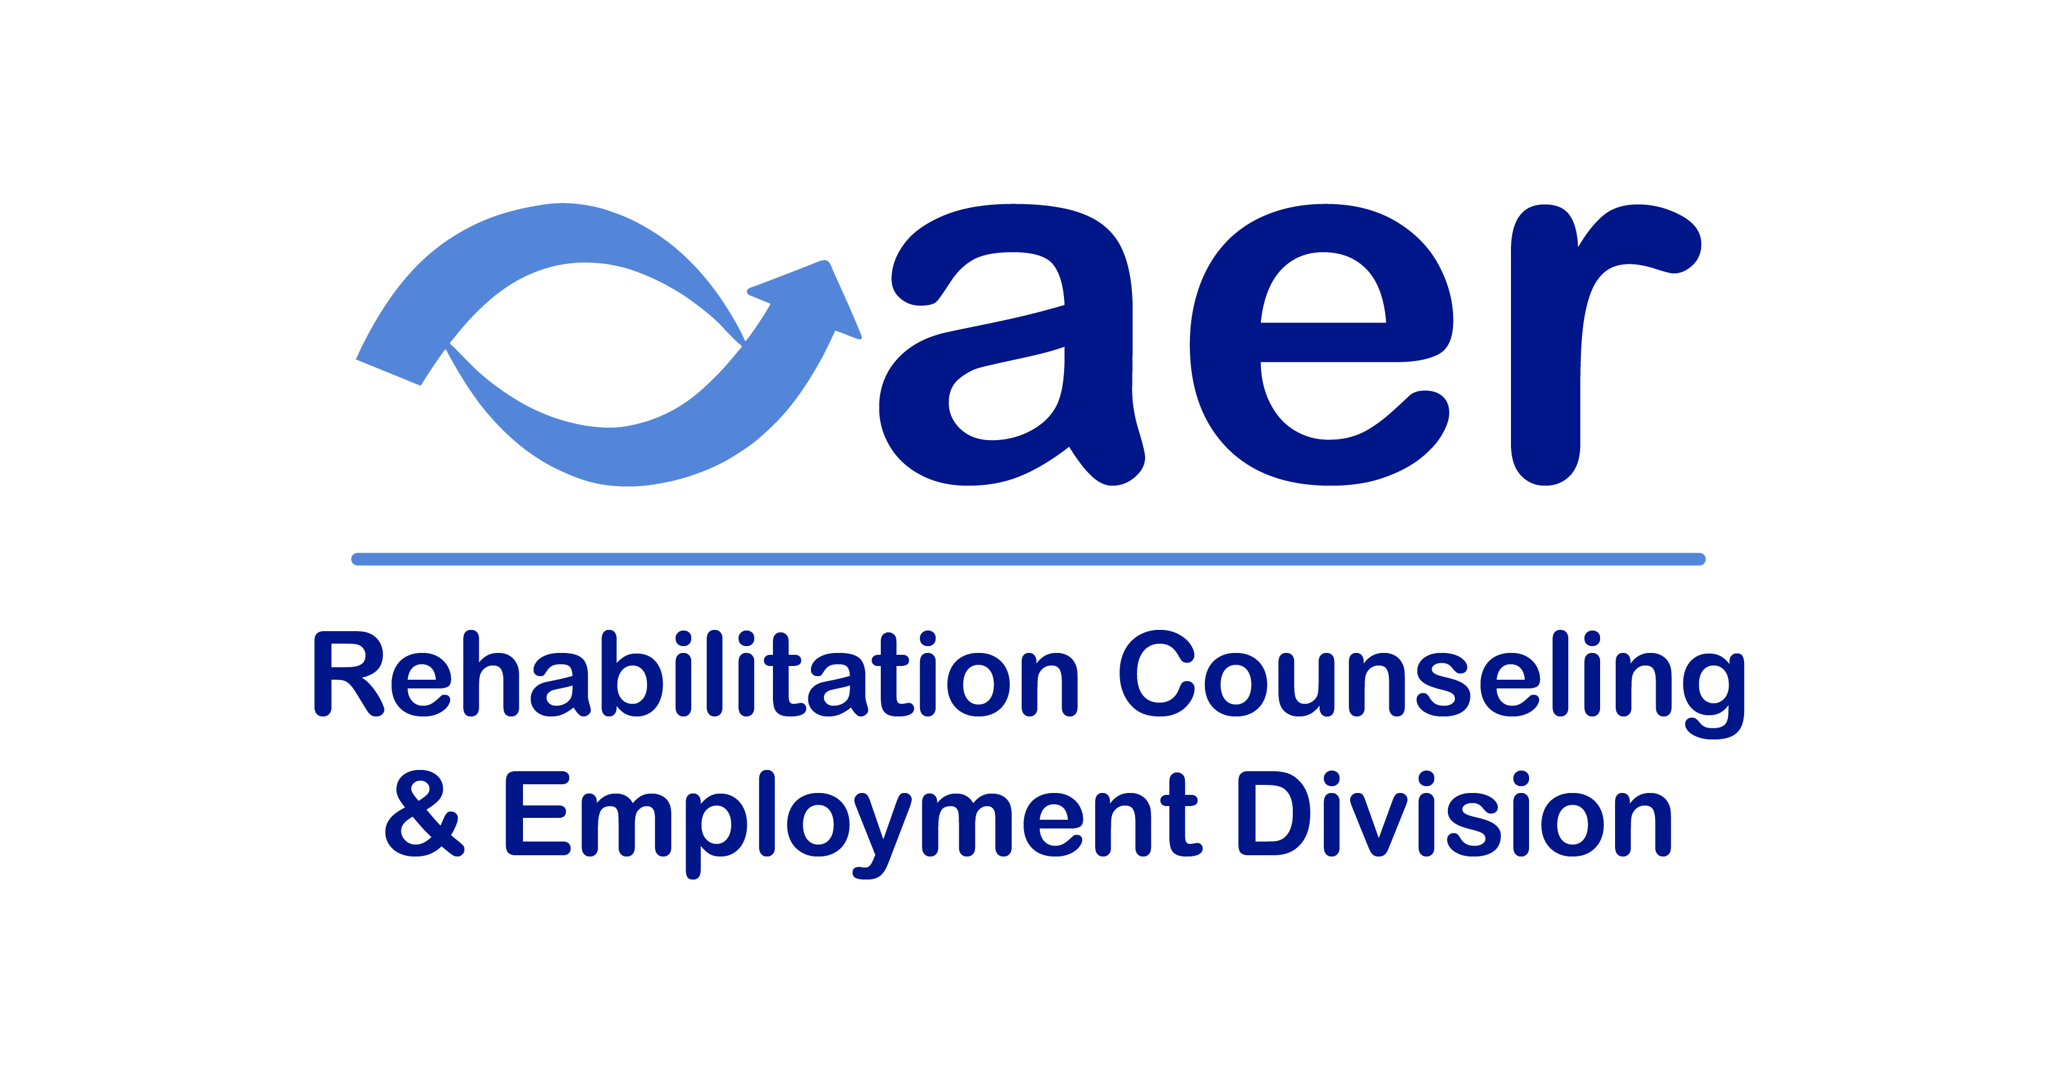

**Rehabilitation Counseling and Employment Division**

**Spring 2025 Newsletter**

**In This Issue:**

**From the Chair**

**Sources for CE Credits**

**What’s New At the NRTC**

**Section 504**

**Meet Your Division 2 Board**

**Social Media Group**

**Contact Us**

# **From the Chair**

**By Steve Kelley CVRT, CRC. CATIS**

Greetings All!

Welcome to the Spring newsletter of 2025 for the Rehabilitation Counseling and Employment Services Division of AER!

Your division Officers are meeting monthly to lay out plans for Division 2 in the upcoming year. Some of you may have noticed we now have a Facebook page [**Rehabilitation Counseling & Employment for people w/ blindness / low vision**](https://www.facebook.com/groups/162453225927594/)**.** Please check it out, share your questions and offer advice to other posts.

Please take a moment to check out the [Division 2 Section](https://www.aerbvi.org/division_rehabcounselemploy) of AERBVI’s website. The archived newsletters are again available for downloading. If you see any other updates that need to be made, please let me know. Also, I’d very much like to hear from you—if you have something to contribute to the next newsletter, please send it along, or just a note to introduce yourself.

Stay In Touch,

Steve Kelley

# **Sources for CE Credits**

What better way to get your attention than leading off with some resources for CE credits?

* AER has an archived version of our past chair, John McMahon’s webinar on [Applied Ethics](https://www.pathlms.com/aer/courses/47841)
* Mississippi State [National Research and Training Center on Blindness and Low Vision (NRTC)](https://www.blind.msstate.edu/training) has some 72 courses free, and many with CRC credit
* [Helen Keller Services](https://www.helenkeller.org/courses/) has a selection of online courses with CRC credit

# **What’s New at the NRTC**

The NRTC has a new article summary on our publication [*Comparison of Assistive Technology Use and Beliefs Among Employed and Unemployed People Who Are Blind*](https://www.blind.msstate.edu/sites/www.blind.msstate.edu/files/2024-12/Comparison%20of%20AT%20Use%20and%20Beliefs.pdf). The purpose of this study was to explore whether assistive technology (AT) use, skill levels, training needs, and self-efficacy differed between employed and unemployed individuals who are blind or have low vision (B/LV).

To learn more about our research takeaways, [visit our Article Summaries page on our website](https://www.blind.msstate.edu/research/article-summaries)!

# **Section 504**

Section 504 of the Rehabilitation Act has been in the news as a result of the lawsuit by 17 states. If you live or work in any of these states: Texas, Alaska, Alabama, Arkansas, Florida, Georgia, Indiana, Iowa, Kansas, Louisiana, Missouri, Montana, Nebraska, South Carolina, South Dakota, Utah, and West Virginia, you may want to get more actively involved. For more information and to learn what you can do to support Section 504 check out the webinar by Disability Rights, [Disability Rights Community Briefing](https://youtu.be/BW5QU45HZyc?si=K9_EIQ8dXvj3WGFt): What Can You Do to Stop the Attack on Section 504? Held February 12. Check out the [updated webinar materials](https://dredf.org/disability-community-briefing-what-you-can-do-to-stop-the-attack-on-section-504/).

# **Meet Your Division 2 Board**

**Steve Kelley CRC, CVRT, CATIS**

**Chair**

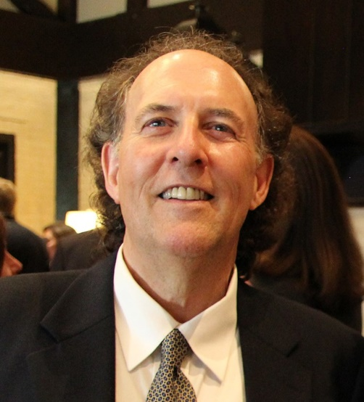Steve Kelley is an Assistive Technology Specialist at Hadley. He also maintains the website lowvisiontech.com and is a regular writer for Access World and VisionAware. Steve holds MAs from University of Arkansas Little Rock (UALR) in both vision rehabilitation and rehabilitation counseling. Steve has worked in the field of vision rehabilitation and access technology for 20 years, first as an itinerant VRT at an agency in Southern Maine, before his current position at Hadley, working with clients remotely. Steve is currently chair of the ACVREP SME committee, and past co-chair of the Access and Technology Division. Steve is a recipient of the Susan and Paul Pnchillia VRT Publication Award and the 2015 Thomas Caulfield Award.

Steve Kelley  
[stevenk@hadleyhelps.org](mailto:stevenk@hadleyhelps.org)800-323-4238 X2830

**Ian Shadrick EdD, CRC, CVE, CVRT, FNRCA**

**Past Chair**

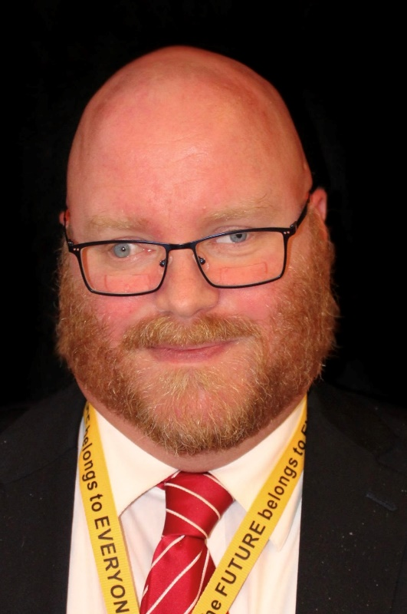 Ian Shadrick is a Blind Rehabilitation Specialist and Subject Matter Expert with Kapili Services, at the Vision Center of Excellence. He is also an Adjunct Assistant Professor in the vision programs at Hunter College (CUNY) where he teachers in VRT, O&M and TVI programs. He also provides rehabilitation counseling, adjustment counseling, VRT and assistive technology training and services to youth and adults nationally. He holds a masters in rehabilitation teaching from Western Michigan University, masters in Rehabilitation Counseling from the University of Arkansas Little Rock, Graduate Certificate in Orientation and Mobility from Missouri State University, and Doctorate of Education in Special Education Leadership and Educational Leadership from Gwynedd Mercy University. His research focused on factors impacting employment outcomes for people with DeafBlindness.

Ian is a former state administrator of VR services for transition and children’s services, and has been a rehabilitation counselor, vision rehabilitation therapist, and blind rehabilitation instructor. Additionally, his experience includes serving as university faculty and program coordinator of blindness and low vision, international educator, private consultant, federal consultant to the DoD and VA, and research associate at a national technical assistance center on post-secondary transition.

Ian is a past chair if the VRT division, and prior AER board member for adult services and Chair for the Council of Division Chairs. He is also a Past President, of the National Rehabilitation Counseling Association, where he holds the rank of Fellow (FNRCA). He is also President of the Association of Vision Rehabilitation Therapists (AVRT). He also served as a Co-Chair of the VRT SME committee for ACVREP. Ian is a recipient of the AER John H. McAulay award, and Alice Raftary award from the VRT division. Dr. Shadrick is a certified rehabilitation counselor, certified vocational evaluation expert, and certified vision rehabilitation therapist. His research focuses on factors affecting employment for those with blindness or dual-sensory loss, access technology, personnel preparation, public health, and legislation.

**Christine Telford**

**Chair Elect**

 Christine Telford is a dedicated professional with over 15 years of experience in vocational rehabilitation, specializing in services for individuals who are DeafBlind. Currently serving as the Regional Service Coordinator at the Helen Keller National Center in Boston, Christine supervises a team of DeafBlind Specialists and Rehabilitation professionals. She effectively collaborates with various stakeholders to enhance the inclusion of DeafBlind youth and adults in the HKNC National Registry. Previously, Christine was a DeafBlind Specialist at HKNC, where she focused on providing one-on-one vocational rehabilitation services to help consumers achieve their employment goals. Her earlier role as an Orientation & Mobility Instructor at the Lighthouse for the Blind and Low Vision honed her skills in teaching clients to navigate their environments independently.

She is the President of the NE/AER Chapter and has served on several State's AER Chapter Boards in the past. Christine holds a Master’s degree in Rehabilitation of the Blind from the University of Arkansas at Little Rock and is a Certified Orientation & Mobility Specialist. She has also completed a Bachelor of Science in Deaf Studies from Towson University and holds certifications in sign language interpreting.

Christine Telford | Regional Representative

she/her/hers

Helen Keller National Center

44 Lafayette Rd

P.O. Box 1268

North Hampton, NH 03862

(p) 516-242-0357

(m) 617-865-4509 VP

ctelford@helenkeller.org

**Nancy Parkin-Bashizi M.A., COMS, CVRT**

**Secretary-Treasurer**

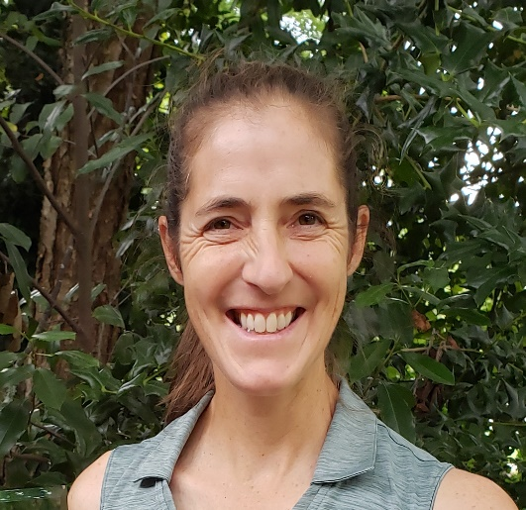Nancy Parkin-Bashizi earned her Master’s Degree in Orientation and Mobility and Rehabilitation Teaching for the Blind from the University of Arkansas, Little Rock in 1995. This year she celebrates her 25th anniversary of employment at Vision Rehabilitation Services of Georgia. For the majority of her time with VRS she has worked as an itinerant teacher, providing O&M, VRT and Job Readiness Training services to clients of all ages.

For about 8 years, Nancy served as the Program Director and Lead Teacher at VRS. In this role she worked to develop new programs to meet the changing needs of clients and provide support and training to her teaching staff. VRS proudly supports professional training programs and hosts at least one OM or VRT intern each summer. Over the past 25 years Nancy has helped guide many new teachers into the field. Though Nancy is originally from Canada she officially became a US citizen in May 2015.

In 2012 Nancy earned her certificate in The Rehabilitation of Persons who are deaf-blind from Northern Illinois University and has used this knowledge to help build programs at VRS that provide training and support to clients who are hard of hearing and / or deaf-blind. Helping her staff learn the skills needed to work with this special group of clients is one of the achievements of which she is most proud.

Nancy has given numerous presentations on many aspects of Vision Loss and Vision Rehabilitation at professional conferences and in-service trainings throughout Georgia and the Southeast. In addition, she has on occasion been an adjunct Professor for the VRT Program at Salus University. Most recently, Nancy has joined the board of GA AER, GA Blind Sports and is a member of ACVREP VRT SME committee.

# **Social Media Group**

As mentioned above, division leadership created a Facebook page to function as a listserv for questions, answers and topic discussions at [**Rehabilitation Counseling & Employment for people w/ blindness / low vision**](https://www.facebook.com/groups/162453225927594/)**.**

**Potential Topics Include Such Areas As:**

* Pre-Employment Transition Services
* RSA Updates & Policy Concerns
* Customized Employment
* Private Rehabilitation Concerns

Please check out the page to share your thoughts. Do you have another listserv or page where you exchange info? Let us know.

# **Contact Us:**

**Chair: Steve Kelley**

[stevenk@hadleyhelps.org](mailto:stevenk@hadleyhelps.org)

**Chair-Elect: Christine Telford**

[ctelford@helenkeller.org](mailto:ctelford@helenkeller.org)

**Secretary-Treasurer: Nancy Parkin-Bashizi**

[nancy@bashizi.com](mailto:nancy@bashizi.com)

**Past Chair: Dr. Ian Shadrick**

[Ian.shadrick@gmail.com](mailto:Ian.shadrick@gmail.com)

**Editor’s Note:** If you find any errors, or would like to suggest articles in the future, please contact Steve Kelley.