ANNUAL IMPACT STATEMENT 2021

Association for Education and Rehabilitation of the Blind and Visually Impaired

AER Accreditation Council

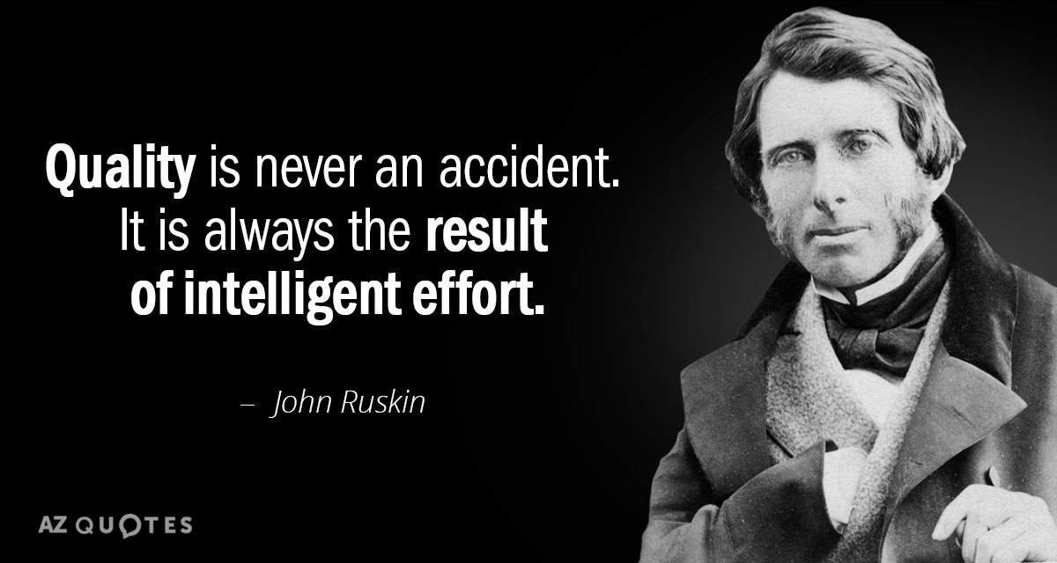

January 2022

MESSAGE FROM THE CHAIR OF AER ACCREDITATION COUNCIL – Michele Basham

THE MAIN GOAL FOR 2021: COMPLETE CHEA PREPARATIONS

AER Accreditation Council entered 2021 with the goal of completing its vigorous exploration of all aspects of organization, policy and procedures as needed to be successful in achieving recognition by the Council for Higher Education Accreditation (www.CHEA.org). This process generally takes about 18 months. By year’s end, the updates and new policies and procedures were completed and the CHEA Recognition committee team commenced writing the application narrative and organizing all materials according to each standard.
- AERAC’s work related to our CHEA Application was spearheaded by a CHEA Recognition Committee, reporting to the Higher Education Accreditation Commission which oversees all aspects of accrediting personnel preparation programs in universities. The committee conducted a very thorough overhaul of the AER Accreditation webpage, standards, policies and procedures, and handbook with particular emphasis on accessibility, greater transparency and a commitment to streamlining practices. Feedback from accredited programs and the many professionals who served on review panels in 2021 was a major factor in identifying and resolving issues.
- Target for submission to CHEA was set for March 2022 so that CHEA’s processes can be completed for a decision by December 2022. March 2022 update: the application has been submitted!

ESTABLISHMENT OF OSAC: ORGANIZATIONS AND SCHOOLS ACCREDITATION COMMISSION

Our work on CHEA Recognition also affected the conduct of accreditations for organizations and specialized schools for the blind. With its very first meeting in January, AERAC began studying the possibility of creating an accreditation commission to reflect expertise in needs and issues of these organizations, handle Provisional Accreditation follow ups, review standards for relevance and clarity, and provide all initial decisions for ultimate approval by AERAC, thereby separating the appeals process conducted by AERAC from the initial recommendations.
- The Organizations and Schools Accreditation Commission (OSAC) was officially created in March and a full complement of five members was empaneled in November.
- Coinciding with these organizational steps, the need for greater communication to the leadership of our field was identified, in particular as it related to creating a pool of qualified

reviewers to meet the large list of HEAC and OSAC candidates for accreditation/re-accreditation. A presentation entitled AER Accreditation Program: Earning Trust, Building Leadership was delivered to the virtual VisionServe Alliance conference in April 2021.
- A Diversity, Equity, Inclusion and Accessibility Policy for AERAC was approved 9/30/2021.

KEY INPUT FROM PROFESSIONALS

Input from professionals in the field, review panel members, and university program leaders was a critical part of the functioning of AERAC and its accreditation commissions. Among the decisions impacted were: Policy on Telepractice (remote and/or virtual instruction), Guidance on Hours of Blindfold training for O&M, use of Dropbox and the Self-Study forms in the review process, assessment of Virtual On-Site visits, transparent reporting on the website of AERAC decisions on all higher education programs (accredited and non-accredited), and requirements of faculty in Low Vision Personnel Preparation programs.

- As part of the CHEA Recognition process, the HEAC page on the AERBVI website will include expiration dates of all accredited higher education programs and a link to AERAC decision histories of higher education programs beginning in 2022.

Looking ahead:

- 12 universities will begin their process of accreditation/re-accreditation in 2022.
- 12 organizations are in the process and scheduling their re-accreditations in 2022.

AERAC is here to advance excellence in the field of blindness and low vision…and we are prepared to join you in the work to make it happen.
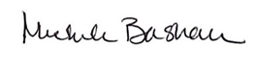
Michelle Basham CHAIR, AER Accreditation Council
*As reported in 2020, the Council for Higher Education Accreditation focuses exclusively on higher education accreditation and quality assurance. Just as accreditation is an opportunity for higher education programs and direct-service organizations and specialized schools to measure themselves against standards of excellence, so too recognition provides AER Accreditation Council a means for self-review and peer review of its management and program. (www.CHEA.org)

ACCOMPLISHMENTS January 2021 – March 2022

Awarded Full Accreditation: 6 HEAC, 8 OSAC

Salus University – LVT ☆ Texas Tech University – O&M
North Carolina Central University – TVI
Missouri State University – O&M and TVI ☆ University of Arizona – TVI

Visually Impaired Pre-School ☆ Lighthouse for the Visually Impaired and Blind
Independence with Low Vision/Elder Care of Alachua
Leader Dogs for the Blind ☆ Centre for Sight Enhancement
Lighthouse of Broward ☆ Florida Outreach Center for the Blind
Cincinnati Association for the Blind and Visually Impaired

Removed Provisional Accreditation and Awarded Full Accreditation: 2 OSAC

New Vision for Independence ☆ Central Susquehanna Sight Services

We wish to convey our heartfelt gratitude to
AERAC Members: Chair Mark Richert, Anthony Stevens, Don Overton, John McAllister, Kathy Beveridge*, Natalina Martiniello*, Paul Olson, Tamara Greenwood, and these members whose terms expired: Eileen Silverman, Sylvia Perez
HEAC Members: Chair John McAllister, Brooke Kruemmling*, Dan Norris, Dawn Anderson*, Dorinda Rife*, Richard Oliver, Sean Tikkun, and these members whose terms expired: Olga Overbury, Bill Penrod, Donna Lee
OSAC Members: Chair Paul Olson, Ronee David*, Sylvia Perez*, Kathy Mullen*, Jeanne Prickett*
CHEA Recognition Committee Members: Chair Bill Penrod, John McAllister, Donna Lee, Dan Norris
*new appointees

HONORING REVIEW PANEL MEMBERS IN 2021

The AER Accreditation Council as well as its Higher Education Accreditation Commission and Organizations and Schools Accreditation Commission especially wish to acknowledge
the 36 dedicated professionals who served on review panels in 2021.

Shannon Darst Sumer Bellinder Julie Hapeman
Cressie Wright Walter Wittich Rene Paquin
Usha Kumar Joyce Mahoney Sierra Dockery
Kevin Hollinger Dr. Lylas Mogk Nancy Prussing
Nancy Parkin-Bashizi Donna-Sue Sullivan Jerry Miller
Toni Walls Nick Casias Brendan Tedrick
Carin Sanders Judy Jackson Stacy Kelly
Kristin Opplinger Sue Dalton Irene Brown
Sandra Lewis Tamara Greenwood Scott Smith
Allie Futty Mackenzie Savaiano David Presley
Kristy Plesscher Belinda Rudinger Brooke Kruemmling Peggy Beckley Jennifer Brooks Beverly Bennett

We could not do it without you!
Do you want to join your peers on a review team?
🖰 https://aerbvi.org/the-national-accreditation-council/become-a-reviewer/
📱 703-671-4500
📧 accreditation@aerbvi.org

~~☆~~

