  
**AER Itinerant Personnel Division 16**

June 2025 Newsletter

Hello AER Itinerant Division Members,

As we look forward to the coming summertime, we just wanted to reach out to you. For those who are wrapping up the school year, here are some links that provide guidance, resources, and ideas to make this busy time of the year more manageable:

* [End of the Year Wrap Up for Teachers](https://www.pathstoliteracy.org/end-of-year-wrap-up-for-teachers/)
* [Preparing for Nexy Year – A TVI Checklist](https://www.aph.org/blog/preparing-for-next-year-a-tvi-checklist/)
* [Year at a Glance](https://www.teachingvisuallyimpaired.com/year-at-a-glance.html)

**Itinerant Highlight**

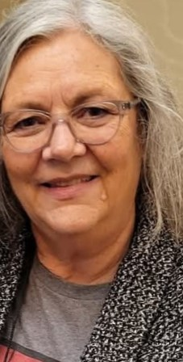Linda Jordan   
  
Linda has 35 years of itinerant experience as both a TVI and a COMS. She is currently employed at Boerne ISD in Boerne, Texas. Linda is a tireless advocate for her students and is a supportive partner to parents and families. She is active in professional organizations and communities of practice. She advises new teachers to connect with other VI professionals by attending networking events along with state level AER conferences and other professional development opportunities. She feels that the VI field is very supportive of each other, all you need to do is reach out. She finds enjoyment in her job by getting to know each student, finding out what makes them tick and then using that information to create meaningful lessons that are fun for both the student and herself. She says, “I love that I get to play everyday at a job that makes a difference”.

**Want To Nominate Your Own Itinerant To Be Highlighted?**

Fill out the [Itinerant Highlight Form AER Division 16](https://docs.google.com/document/d/1mgPn2ubf6XsJ85PWL5mPbKOJNsEBqwtPNftH8iz7pqU/edit?tab=t.0)

**Contact Us**

Want to join us for our next committee meeting in August? Have some ideas and time to volunteer to our division?

Visit our [Division 16 itinerant home page](https://www.aerbvi.org/division_itinerantpersonnel)

**Follow Us On Social Media**

AER Itinerant Personnel

* [Facebook](https://www.facebook.com/profile.php?id=61565170712026)
* [Instagram](https://www.instagram.com/aer_itinerant_personnel_/)

Thank you for your time and support,

Lisha Yochimowitz, Chair

Emily Leeper, Chair Elect

Rosemary Nave Stawasz, Secretary