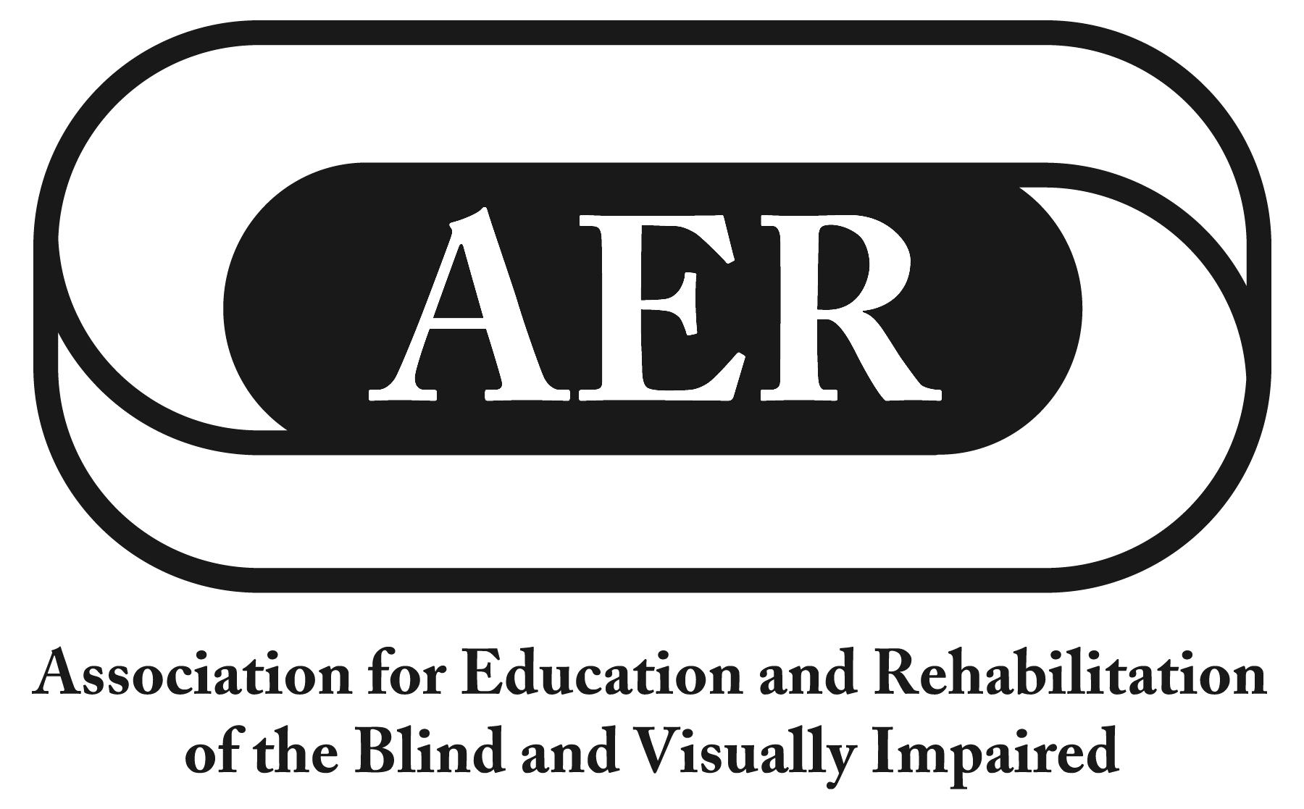
Resolution of the
Association for Education and Rehabilitation of the
Blind and Visually Impaired, July 2016

Autonomous and Connected Vehicles

Resolution Number 2016-3

Authors: Janet Barlow & Susan Langendonk

Whereas Anthony Foxx, Secretary of the U.S. Department of Transportation, predicts that autonomous and connected vehicles will be in use all over the world by 2025;

Whereas autonomous vehicles are vehicles that can perform all driving functions with or without human drivers, and connected vehicles are vehicles with advanced technology to communicate with external systems;

Whereas major investments in research and development are being made by private industry, public agencies, and educational institutions to establish connected and autonomous vehicles;

Whereas National Highway Traffic Safety Administration's (NHTSA) 2016 policy statement on autonomous and connected vehicles does not mention pedestrians;

Whereas much of the material published discusses vehicle connection to "infrastructure" and other vehicles, with no mention of pedestrians or bicyclists;

Whereas in 2013, 4,735 pedestrians were killed in traffic crashes in the United States which averages to one crash-related pedestrian death every 2 hours;

Whereas more than 150,000 pedestrians were treated in emergency departments for non-fatal crash-related injuries in 2013 and pedestrians are 1.5 times more likely than passenger vehicle occupants to be killed in a car crash on each trip;

Whereas children under 14 and elderly pedestrians are overrepresented in these statistics;

Whereas 22.5 million adult Americans 18 and older reported experiencing vision loss;

Whereas autonomous vehicles feel their surroundings with such techniques as radar, GPS, and computer vision, and advanced control systems interpret sensory information to identify appropriate navigation paths, as well as obstacles and relevant signage;

Whereas there are questions about how autonomous vehicles will effectively detect pedestrians who are blind;

Whereas autonomous or connected vehicles may require pedestrians to use wearable technology such a beacons or smartphones;

Whereas wearable technology can be expensive, complex, require maintenance or charging, and may not be accessible to individuals with disabilities;

Whereas AER recognizes that autonomous vehicles may provide increased mobility for some individuals who are blind or who have low vision, if they are able to use and may afford to use such vehicles;

Whereas vehicles will have to be programmed to make decisions regarding crashes, and the current emphasis on vehicle safety and safety of vehicle occupants (as stated in recent research studies) is a concern for vulnerable users, such as pedestrians and bicyclists; now, therefore be it

Resolved, on this twenty-third day of July, 2016, in Jacksonville Florida, that the Association for Education and Rehabilitation of the Blind and Visually Impaired (AER):

- urges that research and product testing evaluate the effect of autonomous and connected vehicles on pedestrian safety, especially the effect on pedestrians who are blind or who have low vision; and

- urges the Secretary of the U.S. Department of Transportation, the Federal Highway Administration, the National Highway Traffic Safety Administration, the U.S. Architectural and Transportation Barriers Compliance Board and Transport Canada to move promptly to implement results of research to assure the consideration of safety for ALL pedestrians, including those with visual impairments.

