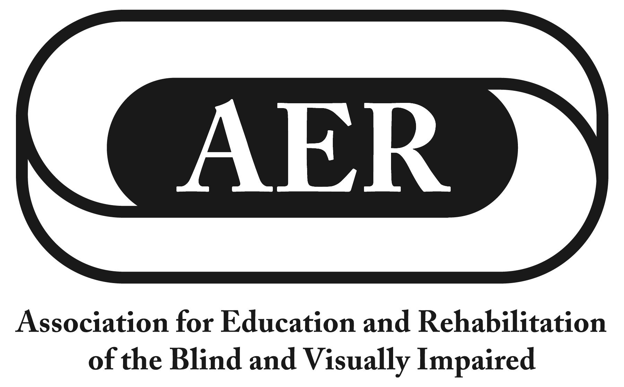

Resolution of the
Association for Education and Rehabilitation of the
Blind and Visually Impaired, July 2016

BANA Board Representation and Collecting Input from Membership

Resolution Number 2016-4

Author: Tina Herzberg

Whereas the mission of the Association for Education and Rehabilitation of the Blind and Visually Impaired (AER) is to support professionals who provide education and rehabilitation services to people with visual impairments;

Whereas AER gives professionals and consumers in the field a collective voice to advocate for and with people with visual impairments;

Whereas AER is dedicated to serving its members needs by implementing and maintaining high professional standards;

Whereas decisions are currently being made by the Braille Authority of North America (BANA) that will affect all students and adults who read braille in the United States and Canada for many years to come; now, therefore, be it

Resolved, that:

- there shall be formal mechanisms in place to ensure that the membership is routinely provided an opportunity to share input to their BANA Board representative and that the membership's collective voice is being represented in the votes that happen within the BANA Board meetings. Formal mechanisms should include a survey of the membership once before the May meeting and once before the November meeting each year to obtain input before voting, so the votes of the BANA representative represent the· collective voice of the membership. The surveys should be supplemented with open sessions with the BANA representative at conferences and use of existing AER listservs.

- the qualifications and responsibilities of the BANA Board representative be included in the policy and procedures manual.

