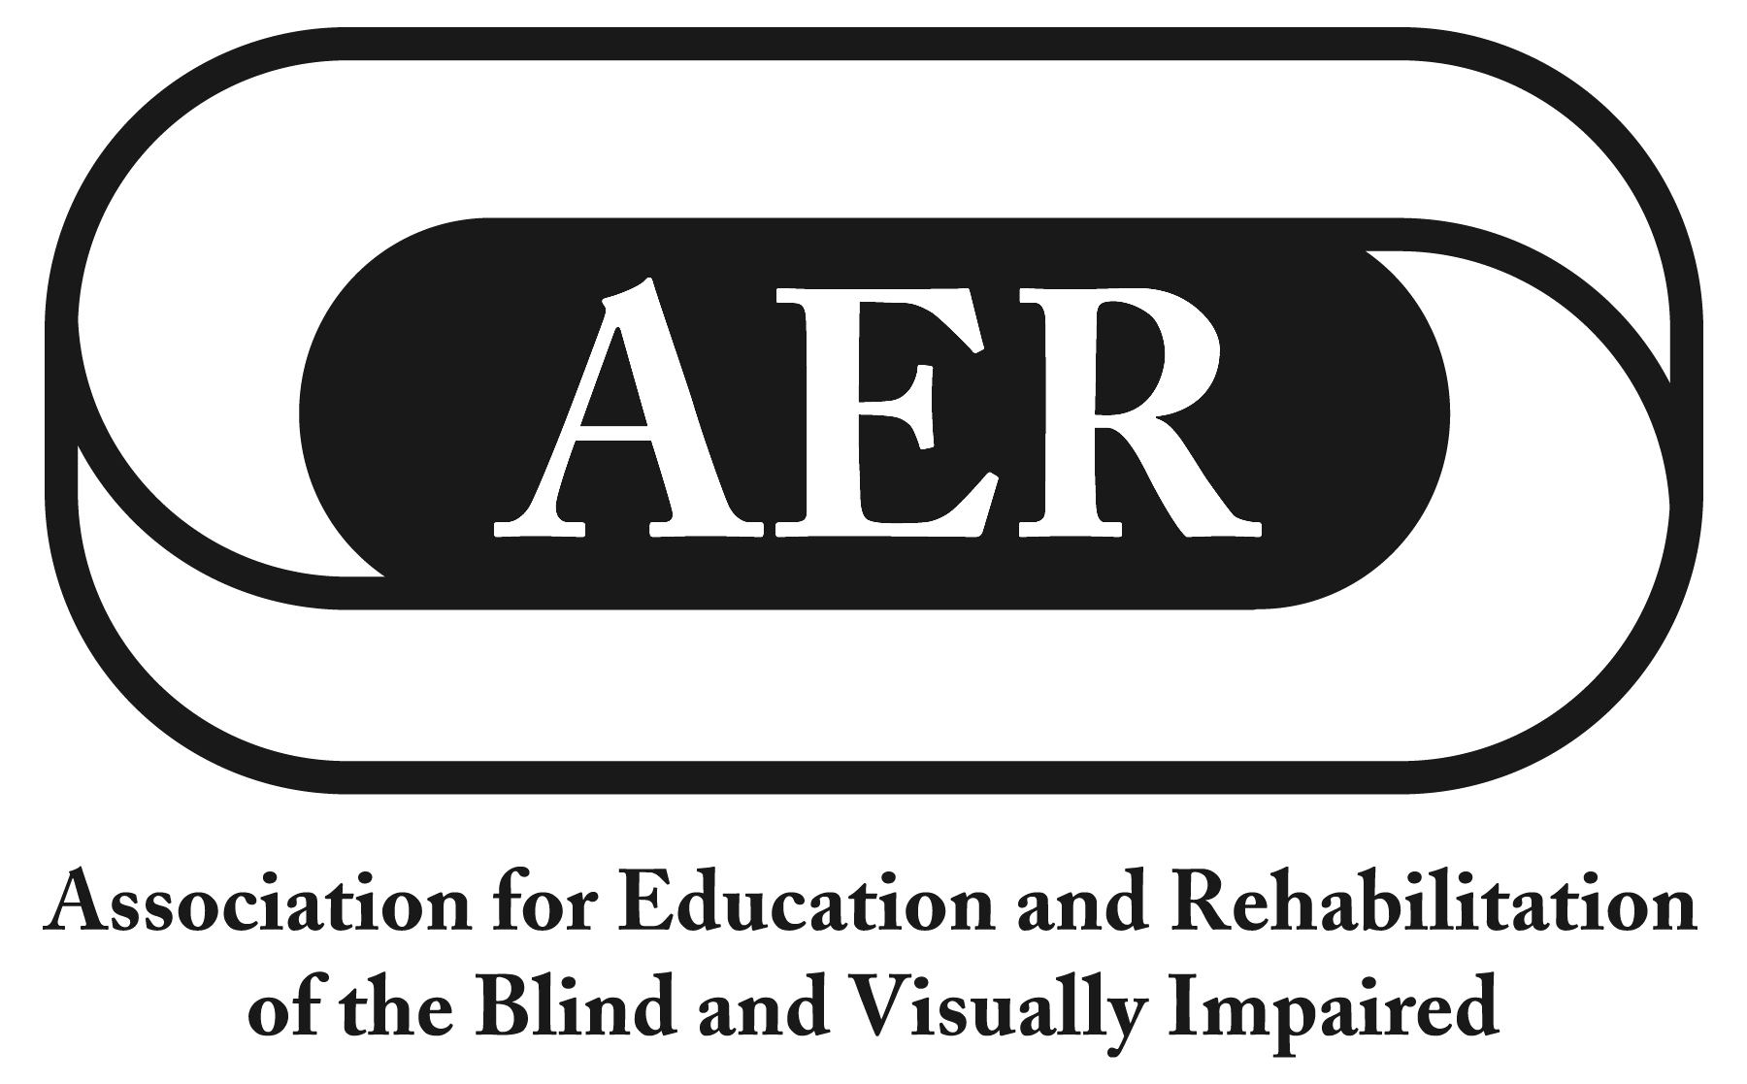
Resolution of the
Association for Education and Rehabilitation of the
Blind and Visually Impaired, July 2016

Roles and Responsibilities of Teachers of Students with Visual Impairments to Teach the Expanded Core Curriculum

Resolution Number 2016-5

Authors: Ting Siu & Frances Mary D’Andrea

Whereas the mission of the Association for the Education and Rehabilitation of the Blind and Visually Impaired (AER) is to support professionals who provide education and rehabilitation services to people with visual impairments;

Whereas AER represents stakeholders in the education and rehabilitation of individuals with visual impairments;

Whereas AER is dedicated to serving its members by maintaining high professional standards as aligned with the needs of individuals with visual impairments;

Whereas the roles and responsibilities of Teachers of Students with Visual Impairments (TVIs) as outlined in the Expanded Core Curriculum (ECC) have been recognized as the scope of practice in serving students with visual impairments;

Whereas the ECC is defined as the body of knowledge and skills that are needed by students with visual impairments due to their unique disability-specific needs and includes: Functional Academic Skills, Orientation and Mobility, Social Interaction Skills, Independent Living Skills, Recreation and Leisure Skills, Career Education, Technology, Sensory Efficiency Skills, and Self­ Determination;

Whereas 2016 marks the 20th anniversary of Dr. Phil Hatlen's landmark publication "Core Curriculum: The Right to Be Different" describing the importance of the ECC;

Whereas TVIs are increasingly challenged to maintain greater breadths of knowledge due to the diverse needs of learners with visual impairments; and

Whereas given that TVIs are already a specialized credential with a shortage of highly qualified TVIs that limit and impact appropriate service delivery in k-12 programs that include students with visual impairments; now, therefore, be it

Resolved, by the Association for Education and Rehabilitation of the Blind and Visually Impaired (AER), on this twenty-third day of July, 2016, in the city of Jacksonville, Florida, that:

- this organization, through its leadership and general members, shall advocate that the ECC continues to define the scope of assessment and instruction that TVIs provide;

- AER will support TVI preparation programs to prepare TVls who can assess and deliver competent instruction in every area of the ECC;

- given the breadth of knowledge assumed in the ECC, that TVls do not need to be an expert in each area of the ECC but rather serve as a primary consultant to locate, obtain, or refer to resources as needed to carry out assessment and instruction in each area of the ECC; and

- AER will continue to recognize and support pre­service programs and the ongoing needs for professional development to ensure that every TVl maintains the skills and resources to assess and instruct in every area of the ECC.

